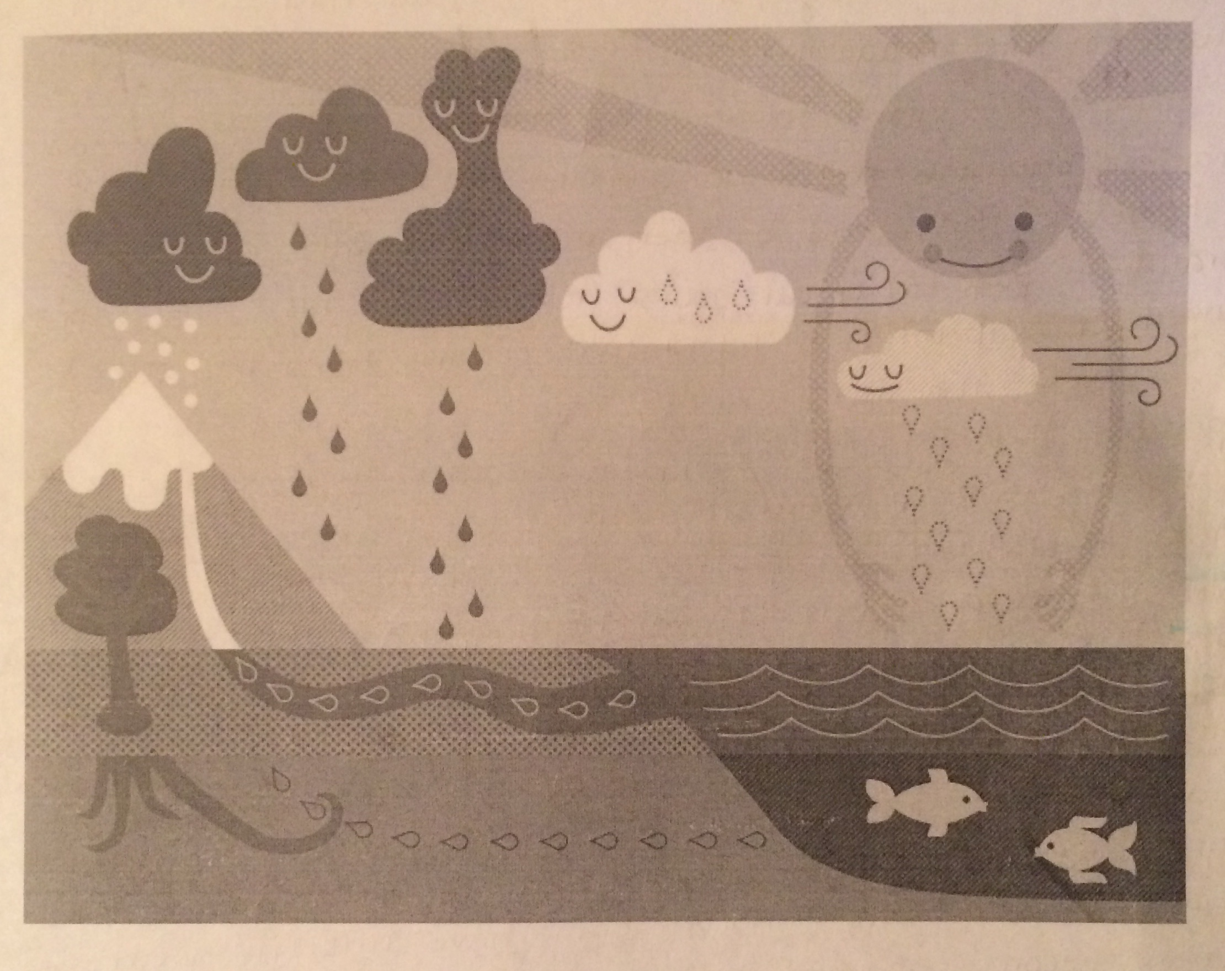

When I saw this image on Google, I just had to laugh because in this image it has the water being gathered up and going to the sun. I consider the “hands of the sun” a limitation because the water vapour is not going to the sun. However this could be seen as a strength because according to page 137 of our course textbook, it says, “the energy required for evaporation or latent heat coming from the sun.” In the photograph, it is showing the sun’s energy that is required for evaporation, but the limitation comes into play because the sun does not reach out, grab the water vapour and bring it directly to the sun. A strength of this photo could also be that it shows that condensation and precipitation are occurring. It also shows precipitation as both rain and snow, which is a strength of the image. A limitation of this image is that is has no labels, which will make student not understand what is happening in the photo. A student will not know that condensation, precipitation, and evaporation are taking place without labels. I believe another strength of this image is that it shows how raindrops can have different journeys. One raindrop may become snow and then melt into the stream and flow into the ocean, whereas, another raindrop could fall down as rain and be used to help a plant grow. I like how this image shows the water flowing sideways into the ocean because that is how the water travels. This image’s limitations hold it back from being considered a good resource to use. This image is still showing rain going through somewhat of a cycle, which is not the case because water does not go through a cycle, but more through a system.

